CNSL Lab Assignment 7
Neeti Kurulkar
Use packet tracer tool for configuration of 3Router Network using one of the following
protocol RIP/OSPF/BGP

- Network topology
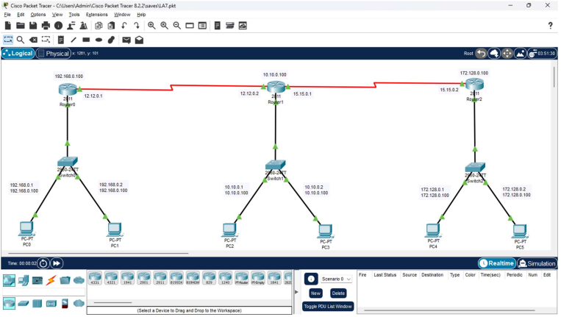

- Routing Configurations
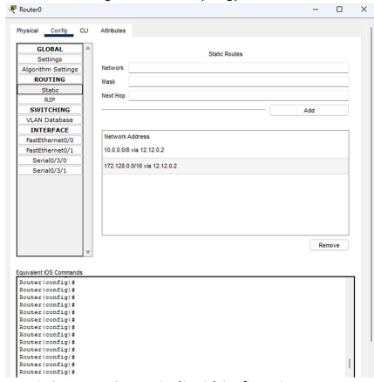
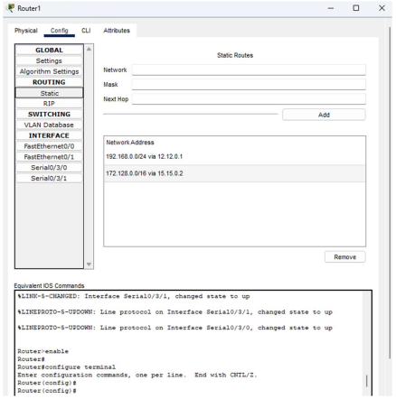
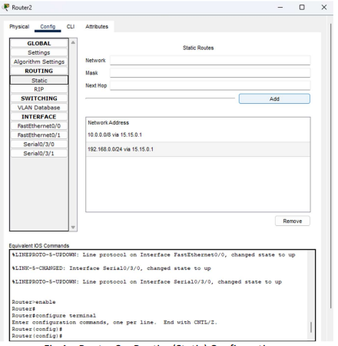

- Checking connectivity from PC0 to other Nodes
